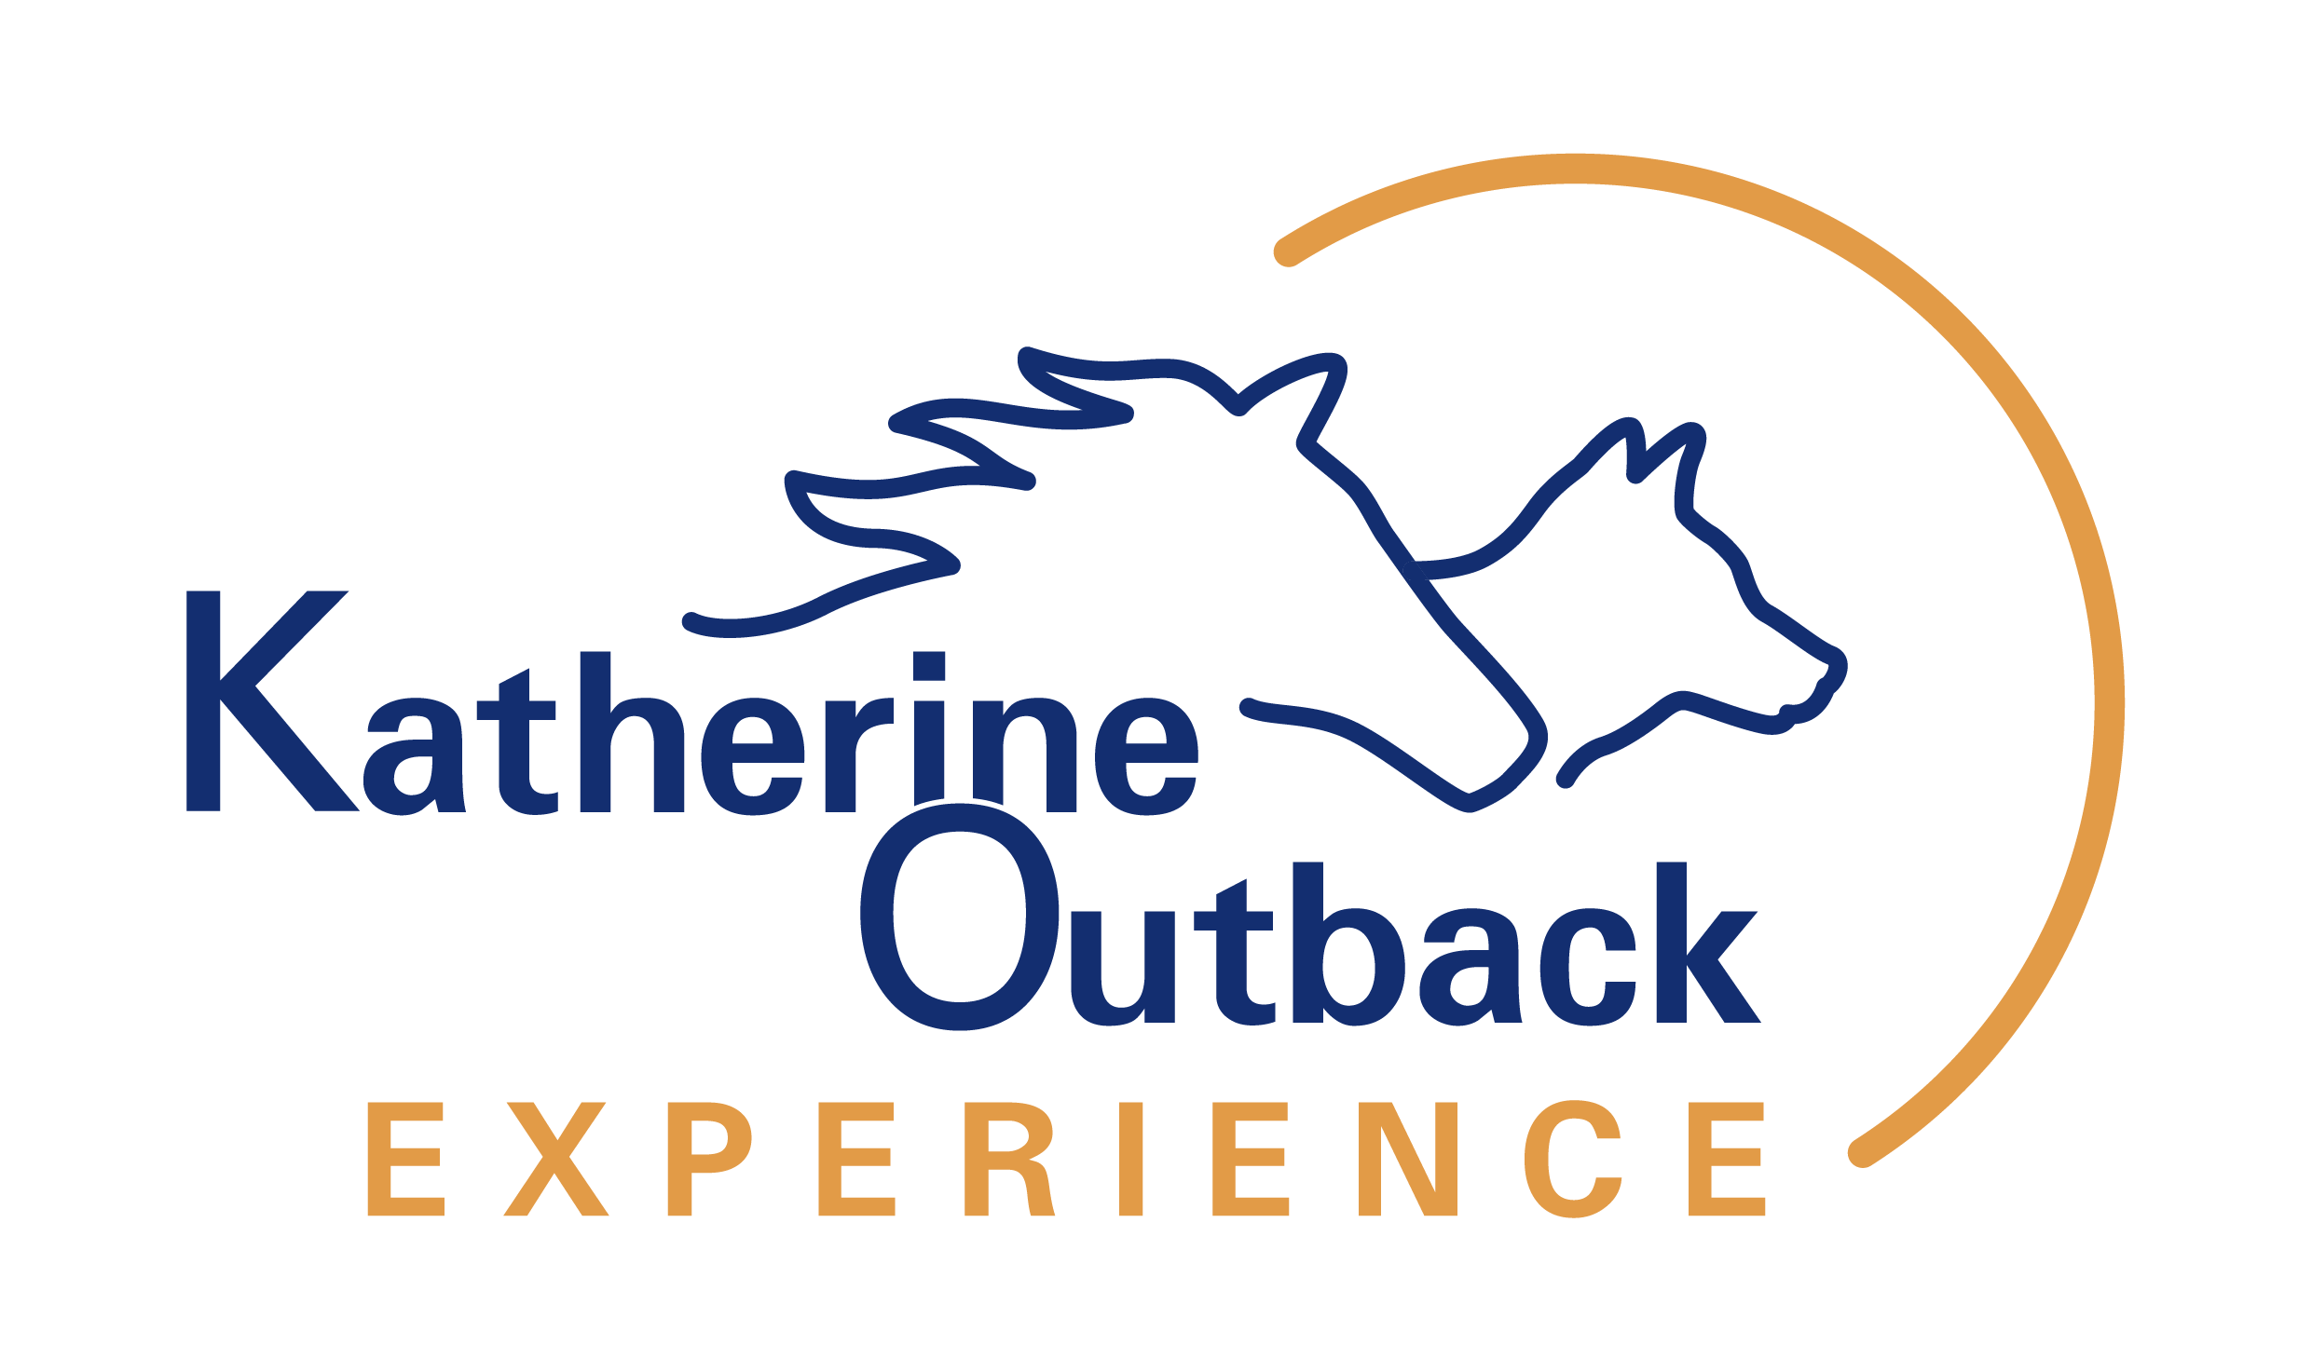

ACCESSIBILITY GUIDE

Revised 1 June 2023
Table of Contents
1. Welcome 3
1.1. Summary of Accessibility and Inclusiveness 3
2. Contact Details 4
3. Overview of Services Offered 4
3.1. Outback Show 4
3.2. Stockman's Workshop 4
3.3. Tailored Horse Rides 5
3.4. Farm Therapy Program 5
3.5. Outback Lunches and Dinners 5
4. Location and Transport 5
4.1. Transport to Katherine 6
4.2. Travel by Taxi 6
4.3. Proximity to Local Emergency Services 7
5. Katherine Outback Experience Venue 7
5.1. Site Plan 7
5.2. Car Park 8
5.3. Pathways 8
5.4. Check-in/ Reception Desk/ Shop 9
5.5. Toilets and Showers 9
5.6. Change Table and Space 10
5.7. Seating 10
5.8. Feeding and Petting the Animals 11
5.9. Dietary Needs 11
5.10. Companion Cards and Concession Rates 12
5.11. Guide Dogs and Companion Animals 12
5.12. Dust and Dirt 12
5.13. Allergies 13
5.14. Heat, Sun and Heat-stress 13
5.15. Emergency Evacuation Procedures 13
5.16. Customer Care and Support 15
6. The Future 15

Welcome
Katherine Outback Experience (KOE) prides itself in creating amazing and memorable experiences that are inclusive and accessible. We are always looking at ways to improve the experience for our guests.

The purpose of the Accessibility Guide is to outline ways in which accessibility has been considered to assist guests with planning their visit.

We encourage guests to contact us direct should they require further information about a specific need or have a specific request. Although we cannot guarantee we can accommodate all needs, we do our best and it never hurts to ask.

Summary of Accessibility and Inclusiveness

The following provides a snapshot of accessible inclusions at Katherine Outback Experience. This is expanded upon further throughout this document:
- Drop-off / Pick-up Area
- Two disabled parking bays close to the entry
- Universally accessible unisex shower and toilet
- Baby change table
- Complimentary tickets for Companion Card holders
- Service animals allowed
- Level access throughout the site (no steps or steep gradients)
- Limited walking
- Recommended for those with low mobility
- All staff have completed online Disability Awareness Training
- Amplified commentary of the Outback Show
- Wheelchair, walker and pram friendly
- Ample seating and shade
- Willing to provide for varying dietary needs
- Willing to tailor experiences to make them more accessible
- Provision of Farm Therapy Program for guests with special needs.
We are passionate about creating an attraction that can be enjoyed by all regardless of race, gender, sexual orientation, cultural beliefs, religion, ethnicity, age, level of mobility, disability (the list goes on).
Some things we have done to improve our inclusive practices include:
- Becoming proud members of Gay and Lesbian Tourism Australia (GALTA)
- Staff training in disability and inclusive awareness
- Provide the option of private group bookings for cultural or ethnic groups
- Flexibility to accommodate guests with special or specific needs
- Cultural training including China Ready Accreditation
- Professional Development including Horse Safety Australia Accreditation so we are better equipped with industry safety standards.

Contact Details
We encourage guests to reach out and contact us if you have a query or cannot find the information you are looking for online.

Below are ways you can contact us to ask questions and make bookings:
- Website
  - www.katherineoutbackexperience.com.au
  - Instant bookings
  - Ability to add special requests, additional information to assist us with preparing for your visit or ask questions at time of booking
  - This is our preferred form of booking
- Phone or Text Message
  - 0447 816 222 or 1300 818 612
  - If we miss your call, please leave a voicemail or send a text message to the mobile number
- Email
  - Email us at bookings@katherineoutback.com.au for clarification, additional information or to make a booking
  - This is our preferred form of contact as it's less likely to be overlooked than social media
- Facebook Messenger
  - We do receive a lot of traffic and spam on our Facebook account, it is possible to get a quick response however at times we do miss messages
- Google Messages
- Instagram Messenger
- In person at 115 Collins Road, Uralla, NT 0852

Overview of Services Offered
Katherine Outback Experience offers a number of experiences and services as outlined below:

Outback Show
- 2-hour outback show of real horse training and working dog demonstrations
- Accessible to wheelchairs, walkers and prams
- Amplified commentary
- Fun for all ages
- Very low walking
- Recommended for tour groups, education groups, independent travellers and families
- Live bookings available online or by email or phone

Stockman's Workshop
- 2-hour hands-on experience with the horses and working dogs
- Easily tailored to the needs of the group
- Recommended for small tour groups of less than 50 guests
- Medium level walking
- Only offered to groups by appointment. Email or call to discuss further with team

Tailored Horse Rides
- ½ hour and 1 hour horse riding lessons and experiences
- Tailored
- Individual or small group
- For safety reasons, rider must meet minimum mobility and cognitive standards
- Weight restricted to 100kg
- Age restricted to 3 years and over
- Only offered by appointment. Email or call to discuss further with team

Farm Therapy Program
- 1-hour to 2-hour hands-on immersive activities with the horses, working dogs and animals
- Tailored to the group's needs
- Accessible to wheelchairs and walkers
- Tailored mobility level
- Recommended for small groups or private bookings
- Only offered by appointment. Email or call to discuss further with team

Outback Lunches and Dinners
- Optional addition of lunches and dinners for group bookings
- Can cater for most dietary requirements/ requests
- Only available as a package with a Show or Stockman's Workshop
- Minimum number of 15 pax
- Must be pre-booked at least two weeks in advance
- Email or call to discuss further with team

Location and Transport
Katherine is a regional centre in outback Northern Territory, Australia. It is located 320 kms south of the capital city, Darwin, at the intersection of major highways; the Stuart Highway and Victoria Highway.
Our address is 115 Collins Road, Uralla, NT 0852. We are just 7km east of the town centre of Katherine in the Northern Territory, Australia.
There is signage on Stuart Highway, at the T-Junction of Byers Road/ Collins Road and into our property on Collins Road. Refer to Location Map below.
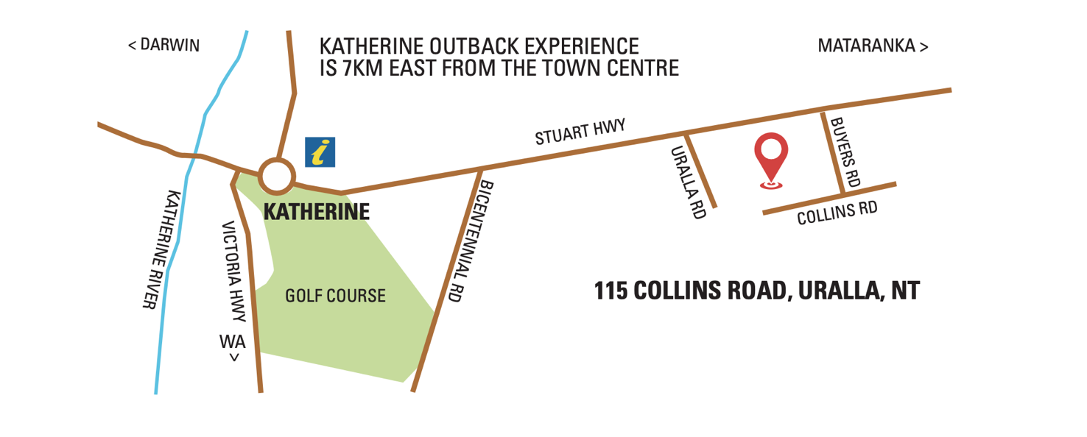
Figure 1: Location of Katherine Outback Experience

Transport to Katherine
Public transport is limited. Most people drive to Katherine from Darwin in the north, Alice Spring in the south, the Queensland border to the east or Kununurra over the border in Western Australia.
Darwin is the closest major airport that is serviced by major airlines including Qantas, Virgin and Airnorth. There are a range of car hire businesses based in Darwin. We would recommend discussing this with Tourism Top End.
There is a local airport at the Tindal Airbase 12 kms east of Katherine Outback Experience. Airnorth provides up to three services per week between Darwin and Alice Springs that stopover in Katherine.
There are a small number of local helicopter operators and fixed wing charter companies also based in Katherine.
The Ghan Railway line extends between Adelaide and Darwin. The Ghan Train is the only passenger train on the line which stops-over in Katherine for three to five hours on its trips between Adelaide and Darwin. The Ghan Train is exceptionally well equipped to accommodate guests with various disabilities however this is a tour in itself (yes, guests have the option to come visit us during the stop over).
Locally there are limited bus options. Katherine Taxi service has a small number of wheelchair accessible vehicles and can be contacted on 131 008

Travel by Taxi
Public transport options in Katherine are limited. There is a taxi service that has some universally accessible vehicles. We recommend booking this service in advance of your visit. Should you wish to arrive by 9am, we recommend booking it for 8:30am. Likewise, do not forget to book your return taxi in advance.
You can contact Katherine Taxi's on 131 008.

Proximity to Local Emergency Services
Despite being in the outback, we are very close to a number of emergency services as outlined below:
- Police Station: 3.8km
- Ambulance: 4.1km
- Fire Brigade: 4.1km
- Katherine Hospital: 7km
In the case of an emergency, we can quickly access emergency support.

Katherine Outback Experience Venue

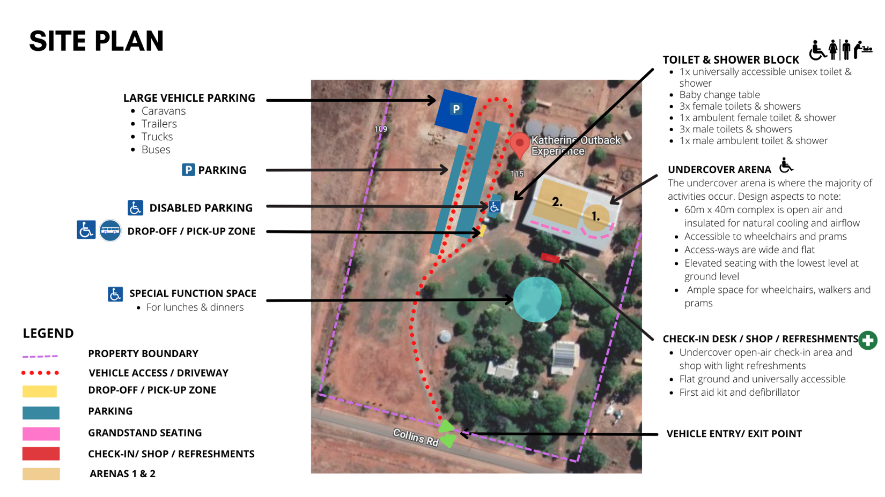
Site Plan
Figure 2: Site Plan of Katherine Outback Experience

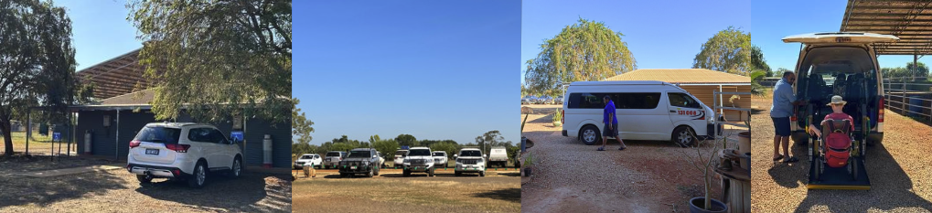
Car Park
Figure 3: Parking at Katherine Outback Experience including designated Disabled Parking Bays, general parking bays, Taxi drop-off/ pick-up area adjacent to Arena 2
KOE has a large car park that includes:
- 90 car bays
- Two disabled car bays adjacent to the toilet block with ample space either side
- Oversized vehicle parking bays for trucks, caravans, motor-vehicles and buses
- Drop-off/ Pick-up area close to the show
- Overflow parking for special events
For those with low mobility, we are happy for vehicles to drive closer to the show arena. We request guests arrange this with staff prior to their visit.
The disabled car park is 50m from the check-in desk and main arena. A guest could move from the car park, check-in, watch the show, visit the shop and return to their car in less than 200m of total distance covered.

Pathways
All pathways throughout the site are flat and made from cracker-dust allowing them to be traversed easily on foot, with wheels and walkers.
Figure 4: Wide flat accessways throughout the site at Katherine Outback Experience

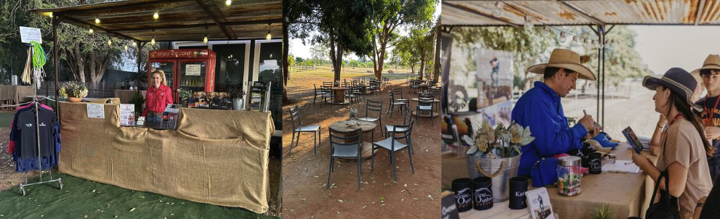
Check-in/ Reception Desk/ Shop
Figure 5: Check-in/ Reception space with lower desk for accessibility. Breakout space with ample space for wheelchairs/ prams to move around tables. Open air space shop space.
The 'check-in/ reception/ shop' area is all outdoors and undercover on level ground. The reception desk has two levels allowing us to service wheel chairs. We regularly step-out from behind the desk to check-in guests and provide a pre-show brief. The space is open plan with wide walkways with more than sufficient space for wheelchairs and prams to move through.
The height of our retail shelves vary and our team will be more than happy to assist you with anything that is out of reach. Unfortunately, with little children of our own, together with cheeky goats, we do need to keep items a tad higher out of their reach.

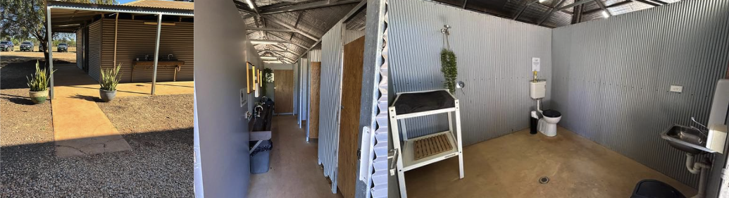
Toilets and Showers
Figure 6: Toilet/ Shower Complex access path. Entry to Ladies toilets. Universally accessible unisex bathroom with moveable baby change table.
Our amenity block at Katherine Outback Experience includes:
- 1x universally accessible unisex toilet and shower that includes a child change table. The cubicle is 2.9m by 2.7m. The bathroom door is 930mm wide
- 4x female toilets and showers including 1x ambulant toilet
- 4x male toilets and showers including 1x ambulant toilet
- Braille signage on all doors.

Change Table and Space
The universally accessible toilet/ shower is 2.9m x 2.7m and has:
- A baby change table
- Braille signage on door
- Sufficient change space
- Low accessible hand-basin.

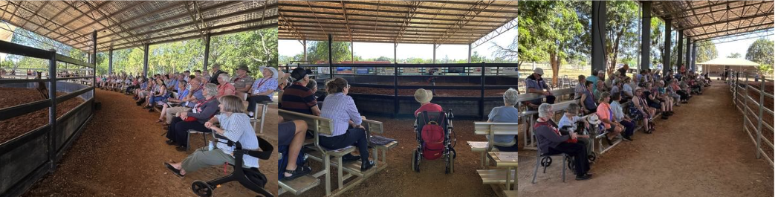
Seating
Figure 7: Three-tier grandstand seating with ample space for wheelchairs, walkers and prams and for members of the travelling party to sit on a chair adjacent to the wheelchair

Seating around Arena’s 1 and 2 includes:
- Three-tier grandstand seating for 140 pax available. The bottom tier of the grandstand is at ground level
- Chairs can easily be added for extra comfort (particularly for guests with lower mobility) or so guests can sit with a member of their travelling party who is using a wheelchair, walker or pram
- Ample space for wheelchairs, walker and prams with great viewing of the show
- Guests offered cushions for added comfort.
There is ‘café style’ seating and low tables in a breakout space between the check-in/ reception/ shop area and grandstand seating at Arena 2. There is sufficient space to manoeuvre wheelchairs and prams through this space (refer to Figure 5).

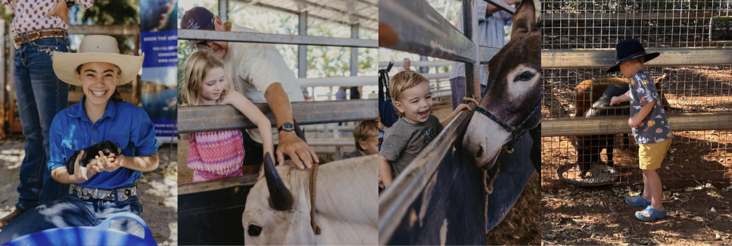
Feeding and Petting the Animals
Figure 8: There are various opportunities to pat and feed the station animals. We will often look for opportunities to bring a working dog or horse to a guest in a wheelchair. We encourage guests to reach out and request this in advance.
There are opportunities to pat and feed animals during the Show and the activities. To maximise inclusion of this activity, we have:
- Added low and high feeding openings in the animal pens so those in wheelchairs and our younger guests can access and feed the animals
- Where possible, we will create opportunities to increase access to the animals where a guest is limited by their mobility by bringing an animal to the guest
Although it cannot accommodate all requests, we do encourage guests to reach out in advance and we can see what we can do.
Please contact us by email at bookings@katherineoutback.com.au to discuss further.

Dietary Needs
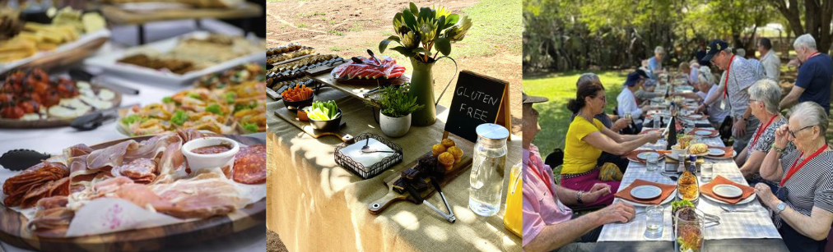
Figure 9: When catering for events, we do our best to accommodate dietary requirements and requests if advised in advance.
We offer some food and drink package options at Katherine Outback Experience. We do our best to accommodate dietary needs where possible. Generally, we make provisions for vegetarian and Gluten Free meals within our menus.
Although it cannot be guaranteed, with prior notification of specific dietary needs, we can see what we can do to accommodate them. Please contact us by email at bookings@katherineoutback.com.au to discuss further.

Companion Cards and Concession Rates
Companion Cardholders are free of charge if they are attending in their capacity as a Carer. A Companion Card is required to be presented at the check-in desk. If booking online, please book a “Free Infant Ticket” for the Companion Card-holders and add the Companion Card details in the ‘Comments’ section.
We provide the following Rate Types:
- Adult: 18 years to 59 years of age
- Senior: 60 years and over
- Student: 6 years to 17 years
- Child/ Infant: 5 years and under
- Family: Two adults and two students.

Guide Dogs and Companion Animals
Guide dogs and companion animals are allowed at this location. Water and shade will be provided.
We do not accept general pets as a biosecurity safety measure for our own team of working dogs and animals. We do request you ensure your Guide/ Companion Dog is up-to-date with vaccinations and worming including Parvo.
For safety, we request you please keep your Guide/ Companion Dog separated from our animals and food preparation areas.
Please reach out to our team via email at bookings@katherineoutback.com.au should you have any further queries.

Dust and Dirt
All efforts are made to keep dust to a minimum including:
- Watering down arenas prior to Shows
- Planting grass and greenery
- Laying of fake turf in common areas
- Cleaning the grandstands, chairs and tables prior to every Show
- Hand basins and soap close-by
Nonetheless, we are a working farm so unfortunately it is impossible to completely remove all dust and dirt. Should dust and dirt be something that could trigger a guest, we would recommend preparing them for what they can expect prior to arriving. We would also recommend avoiding white/ light clothes. Patterned clothes are great for concealing the outback red dirt.

Allergies
This is predominantly an outdoor venue with animals. It is a working farm and despite efforts to minimise dust, it cannot be prevented. At different times of the year, different grasses and trees can cause allergies.
If you suffer from allergies, please carry anti-histamine medication.

Heat, Sun and Heat-stress
We are located in the tropics and most days are over 30 degrees.
The Outback Show is completely in shade, under a huge 40m x 60m insulated shed that is open on the sides for added airflow.
To help keep guests cool and refreshed on warmer days, we pass out cool towels for guests to pop around their necks or hold in their hands. Guests are also offered cold drinking water while watching the show.
We recommend checking the weather forecast before arriving and dressing appropriately for the weather.
It is also important to drink lots of water to stay hydrated.
The animal feeding is outside of the large shed in the shade of trees. We would recommend wearing a hat and applying sunscreen.
For the Stockman's Workshops and Horse Rides, we do spend time in direct sunlight. We recommend being sun-smart including wearing a hat, sunscreen long-sleeve collared shirt and long pants. Both these activities also require closed-in shoes.
Should the sun and heat be triggering, we recommend preparing the guest for what they can expect during their visit.

Emergency Evacuation Procedures
We have an Emergency Evacuation Plan in place for disabled guests. Staff have been trained on how to manage different needs (i.e., blind, deaf, limited mobility and cognitive issues) and have Emergency Checklists and maps to use as a reference during an emergency evacuation situation. In case of an evacuation, all guests will be led safely to the Muster Point (which is accessible to wheelchairs) by a staff member. Refer to the Emergency Site Plan below.
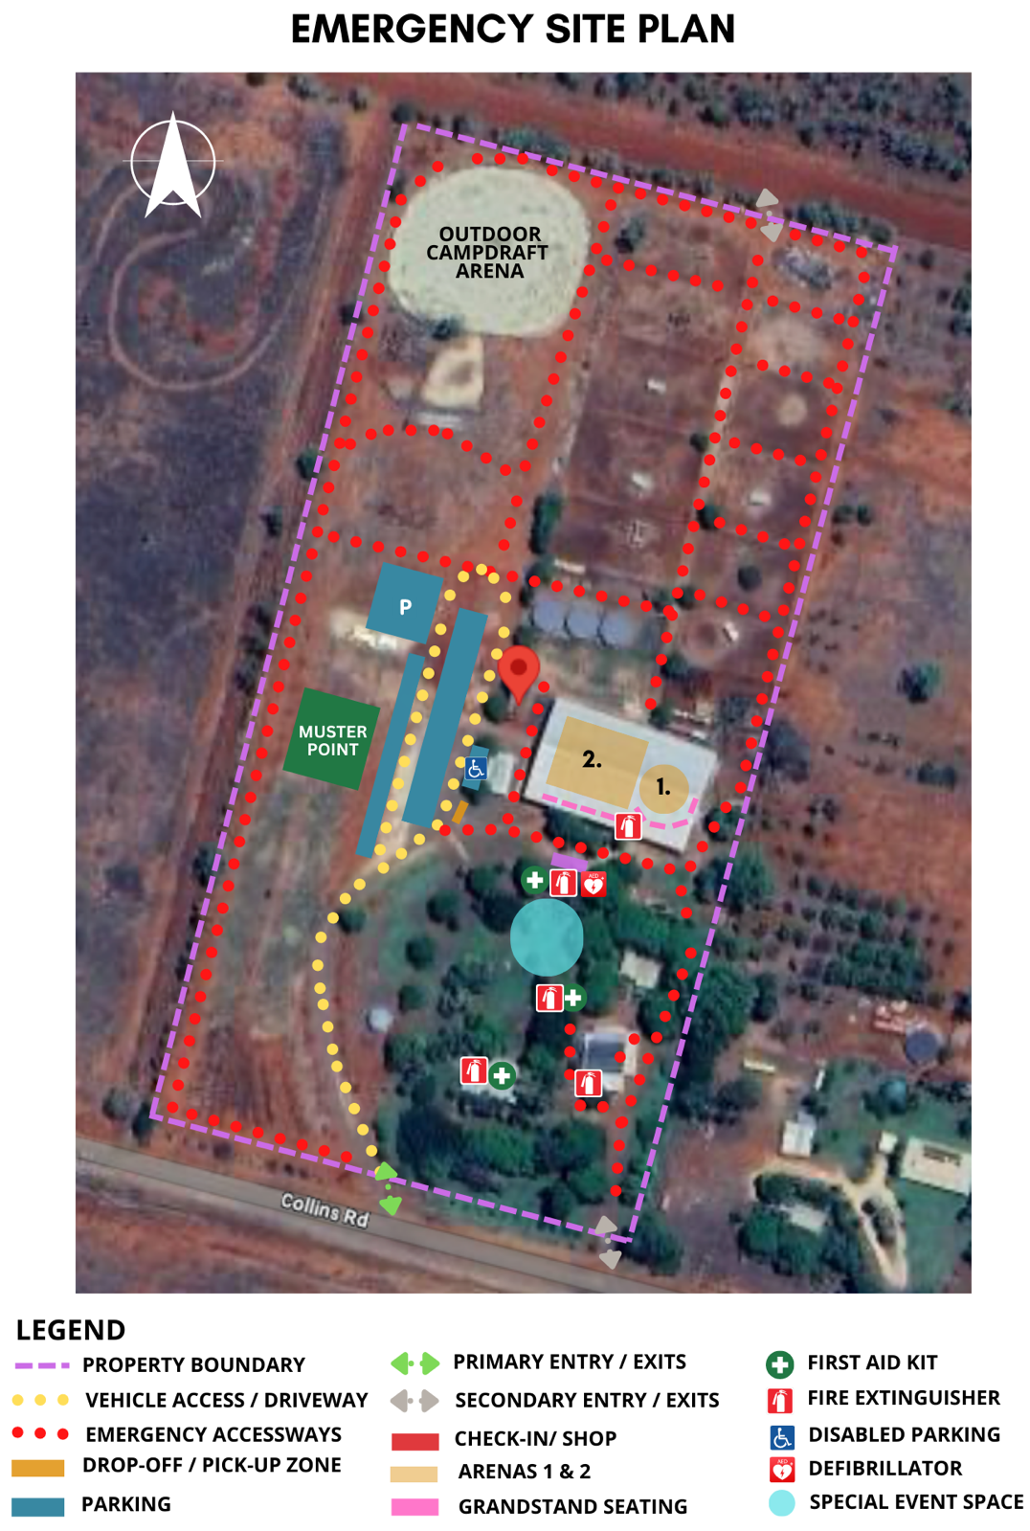
Figure 10: Emergency Access and Evacuation Plan

Customer Care and Support
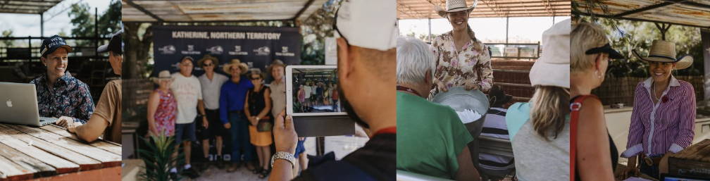
Figure 11: Our Katherine Outback Experience Team are always on hand to assist where they can.

Our friendly team are always willing to assist where possible. To improve our Customer Care Support:
- All staff have disability awareness training
- All staff have customer experience training
- All staff are trained in Basic First Aid and CPR
- We have a defibrillator and emergency medical kit on-site
- We carry hydrolytes in case a guest is in need of additional electrolytes and minerals
- We are accessible by a number of methods including email, phone and in person to answer queries.
We encourage guests to reach out to us either by phone, email or in person to discuss your needs further. We also encourage feedback on how we could better accommodate your needs.

The Future
This Accessibility Guide is a work-in-progress. We realise there is always room for improvement however accessibility and inclusion are front-of-mind in our venue design, product development and decision-making processes.
There are still so many projects we have in the pipeline for the expansion of Katherine Outback Experience and making it more accessible.
We welcome and encourage feedback to help us improve this Guide as well as accessibility and inclusion at our venue. Please do not hesitate to reach out by emailing us at bookings@katherineoutback.com.au direct.

